Booking a lab in the rodent facility

1. Find the correct date in the calendar and make a new appointment (remember that is has to be form your own calendar is you have more than one open)

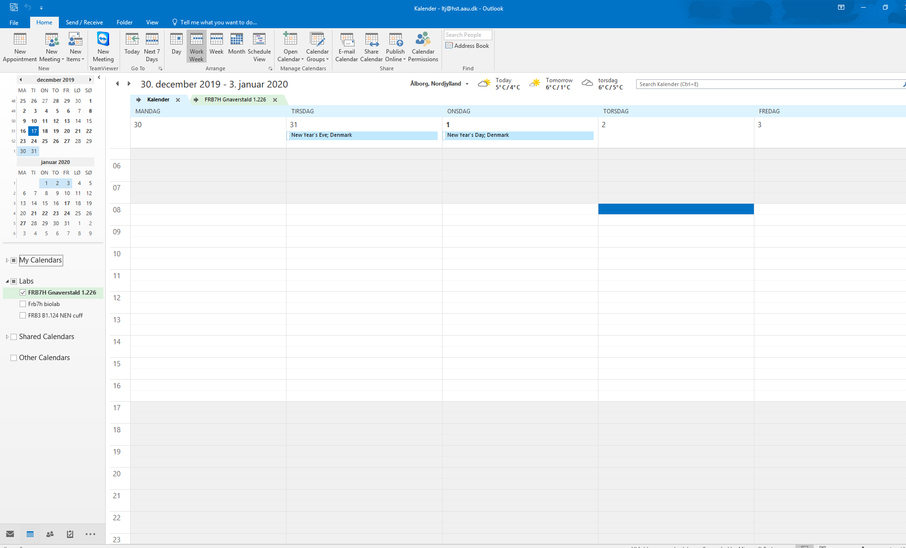

1. Invite the lab (lab nr.) to the event. It’s not enough to write it in “location”. “Location” will be filled out automatically if the lab is invited correctly. This can be done either by writing the address in “To” or choosing the room from the list. First, click “scheduling assistant” and “rooms”:

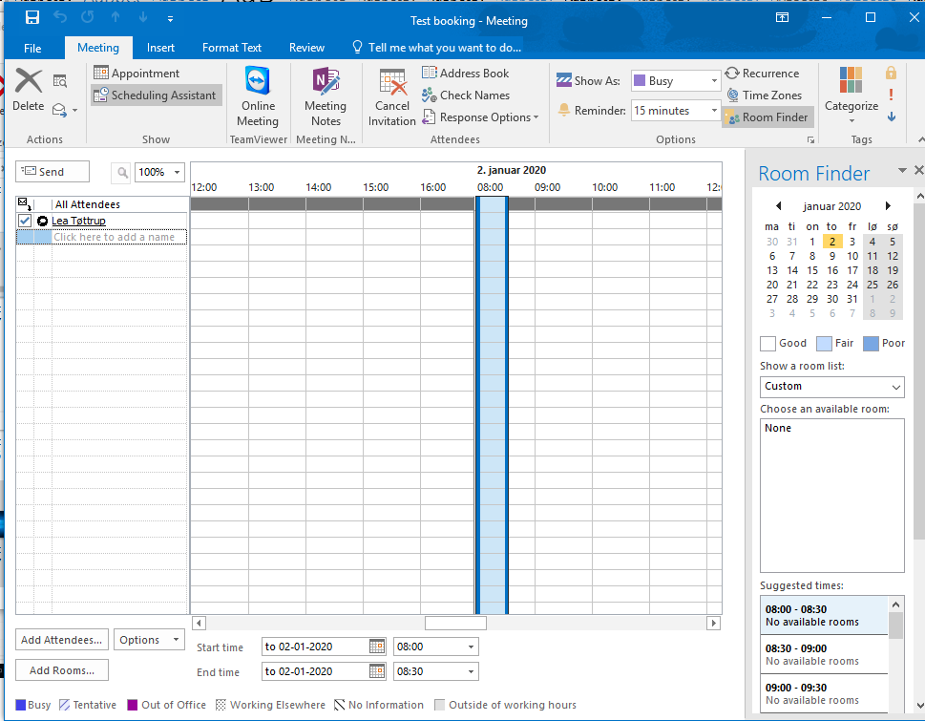

Next, choose your lab from the list and add by clicking “Rooms”. OK cannot be clicked before the room is chosen:

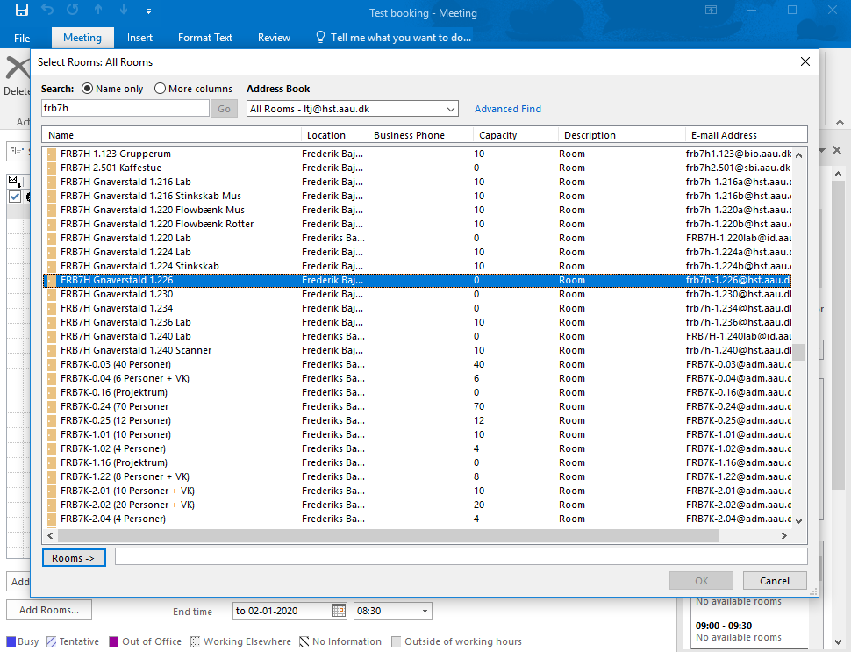

1. Click OK and send. You will receive an email first that “Your request is received and pending approval”. When the rodent facility has accepted the booking you will receive another email that the booking is accepted.
2. If you don’t receive the email, it’s probably because you have booked directly in the lab calendar instead of inviting the lab to an appointment in your own calendar.
3. You can check if the booking have been approved by clicking on the booking under “Attendee response”. If the appointment has not been approved it states that “1 tentatively accepted” and if it has been approved “1 accepted”.

